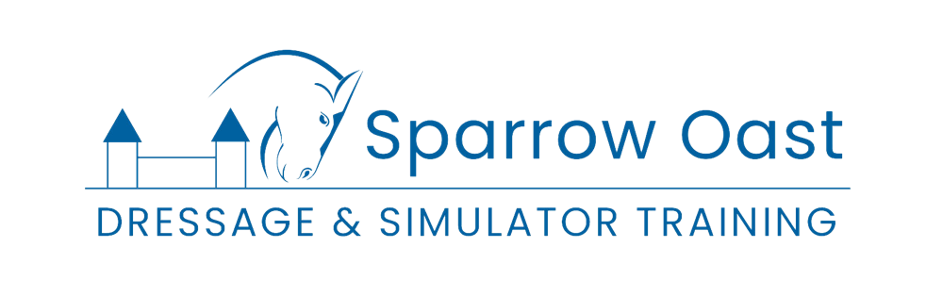

GIFT CARD TERMS & CONDITIONS
Sparrow Oast Stud & Livery is responsible for its gift cards.
In these terms and conditions, we refer to this business as “we” and by related words.
Our gift cards are managed through our partner, GiftUp, and are emailed with a downloadable digital code sent via email.
GIFT CARD GENERAL TERMS
Sparrow Oast reserves the right to amend gift card terms and conditions at any time without prior notice when considered necessary, or to withdraw the card on reasonable notice. Your statutory rights are not affected. Use of the gift card constitutes acceptance of our Terms and Conditions, and we therefore recommend you read them carefully.
CARD FORMAT & CHARGING
The gift card is available in digital format as a code that can be used to make purchases, and you can also choose to download the card in PDF format. You can buy a gift card for yourself, or you can buy one as a present for someone else. All references to the gift card in these terms and conditions are to both formats, unless specified otherwise.

LOST CARDS
Sparrow Oast cannot take responsibility for lost, damaged or stolen gift cards. Any funds spent by an unauthorised person cannot be recovered. You should, therefore, treat the card as you would treat money in your wallet. The Duck reserves the right not to replace any unregistered cards that are lost or stolen.
Sparrow Oast gift cards are not covered by the Financial Services Compensation Scheme – therefore, any funds lost are not insured or compensated.

USING YOUR GIFT CARD
Gift cards can be redeemed in full or used as part payment for all services provided by Sparrow Oast Stud & Livery, except for Events.

CARD TRANSFER & EXPIRY
Gift cards are not transferable and cannot be exchanged for cash. No change or refund will be given but remaining balances will stay on the card for future redemption. Gift cards will expire 12 months from date of purchase or most recent top-up. Any remaining balance will be deducted on expiry.

YOUR DATA
In purchasing and using your gift card, we will collect, store and process personal data in relation to you. Our use of that data is described in our Privacy Policy available at https://www.sparrowoast.co.uk/privacy-policy
QUESTIONS
If you have any questions, please contact us at info@sparrowoast.co.uk

